# Lab 5 Music Player and Audio Amp

By Dhruv Sandesara and Sean Tremblay

**Deliverables (exact components of the lab report)**

1. Objectives (final requirements document)

The objectives of this project are to design, build and test a music player. Educationally, we are learning how to interface a DAC, how to design a speaker amplifier, how to store digital music in ROM, and how to perform DAC output in the background. Our goal is to play Mary had a little lamb. All other objectives are the same as before.

B) Hardware Design

Detailed circuit diagram of all hardware attached to the TM4C123 (preparation 2)

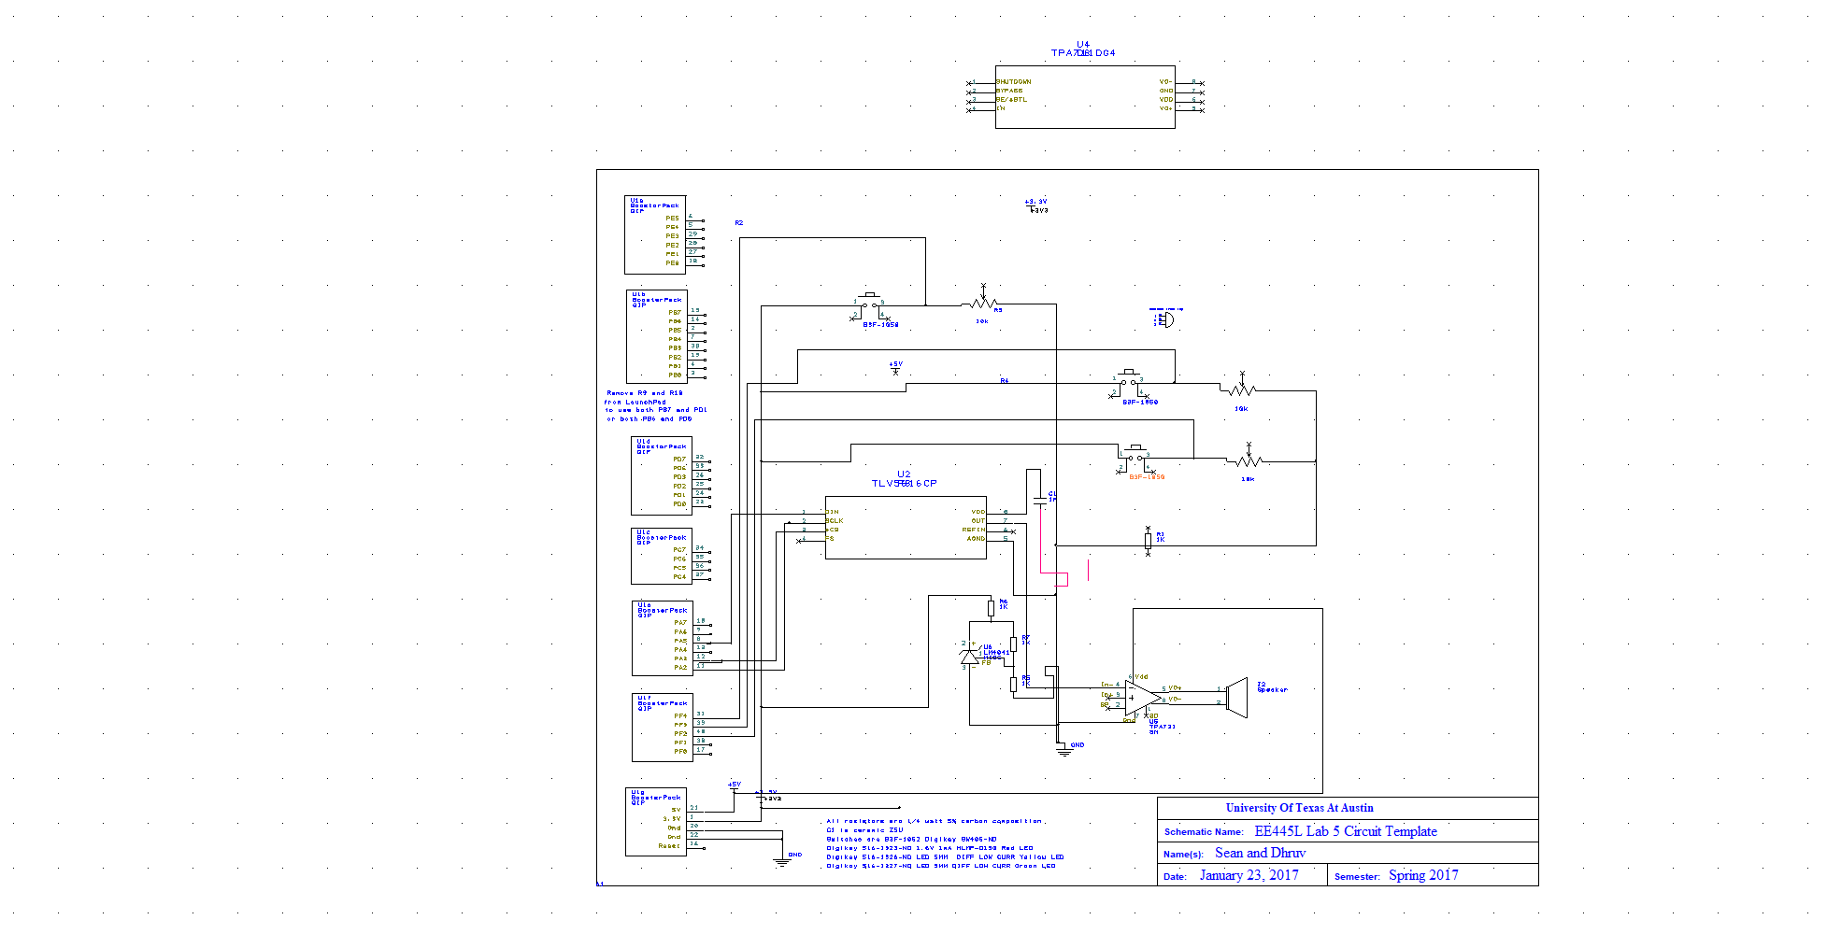

C) Software Design (commit your files to SVN as instructed by your TA)

If you organized the system different than Figure 5.8 and 5.9, then draw its data flow and call graphs

**Same as figure 5.9**

D) Measurement Data

Show the data and calculated resolution, range, precision and accuracy (procedure 3)

Precision of our DAC was 4096.

The resolution was 3/4096=~ 0.01V or 0.732 mv

The range was 0-3.0 V

The measurement values that we got were as foolows

Vref is 1.5 Volts

DAC Output Expected Voltage Actual Voltage

0 0 0

512 0.375 0.392

1024 0.75 0.744

1536 1.125 1.119

2048 1.5 1.336

2560 1.875 1.927

3072 2.25 2.264

3584 2.625 2.640

4096 3.0 2.998

To look at accuracy we first look at all the deviations that we go and add them up and get the average of them all.

Deviations sum: 0+0.017-0.006-0.006-0.114+0.052+0.009+0.015-0.002 = -0.035

Avg accuracy is 0.035/9= 0.004V

In percentage it is 4*100/3000=0.133%

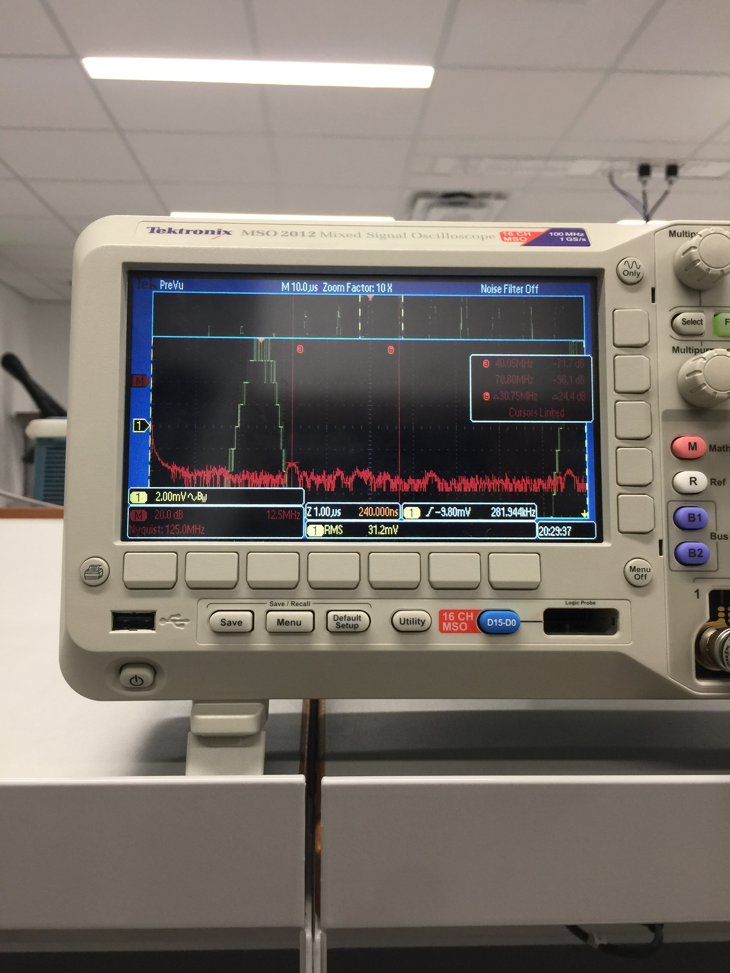 Show the experimental response of DAC (procedure 4) including SNR

The 40mhz was the next big spike at -71 db

The actual wave was at 880 Hz which spiked at 8.84 db. Out SNR therefore was: 8.84-(-71)= ~80db

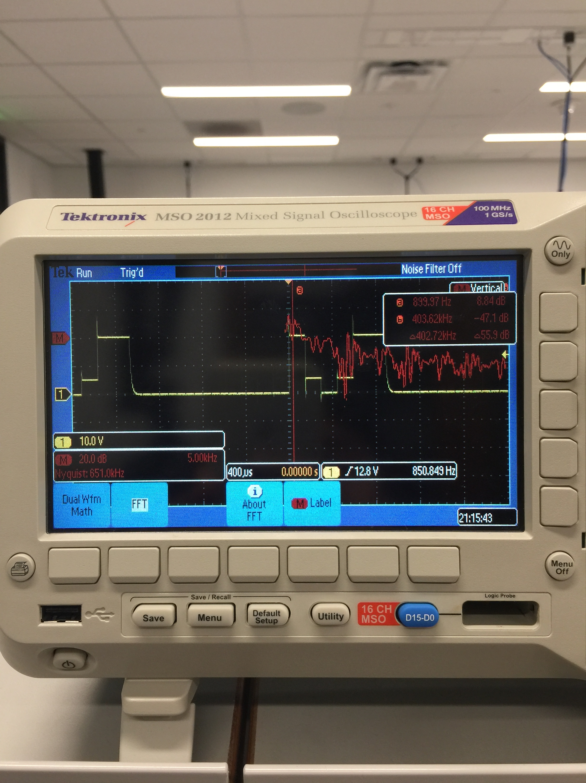

Show the results of the debugging profile (procedure 5)

We had the changing and toggling of the red led in the main loop. When the button is not pressed, it toggles at a faster rate and when the sound starts we can visibly see the toggling slowed down. Below is the screenshot of the toggling connected to the logic analyzer.

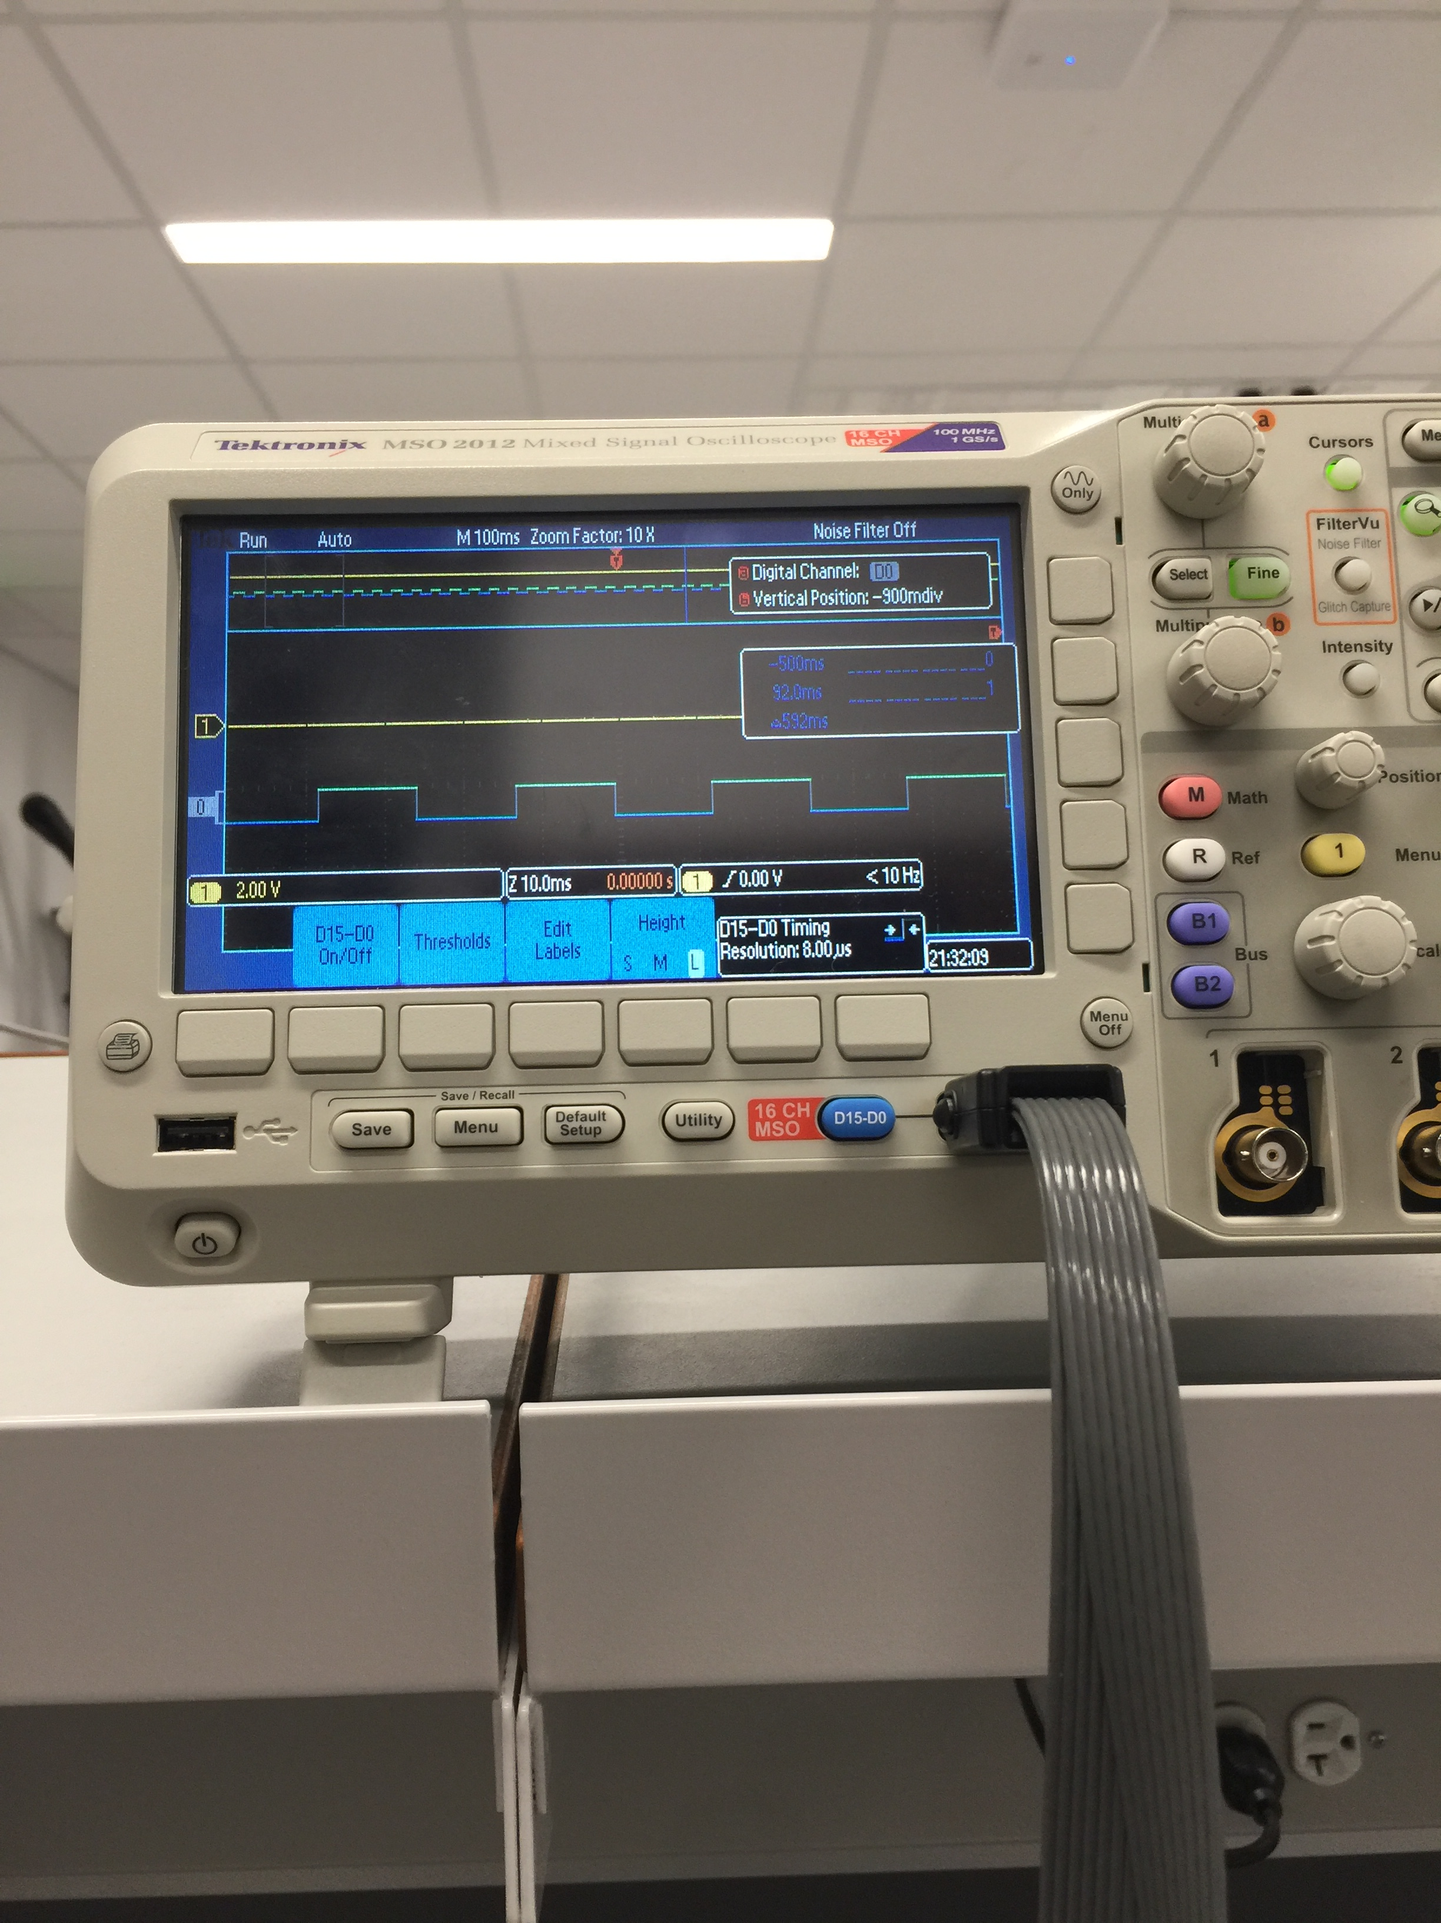

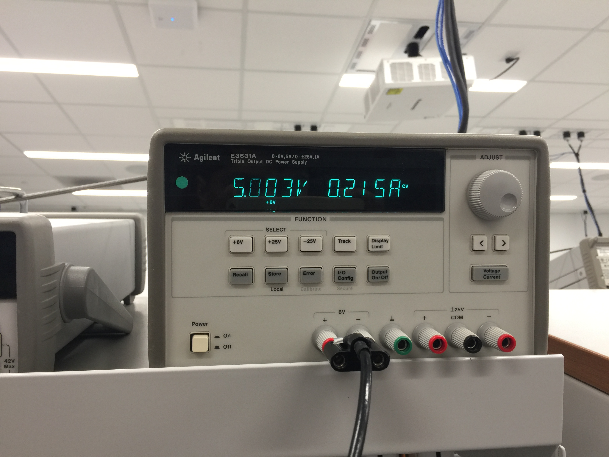With Music

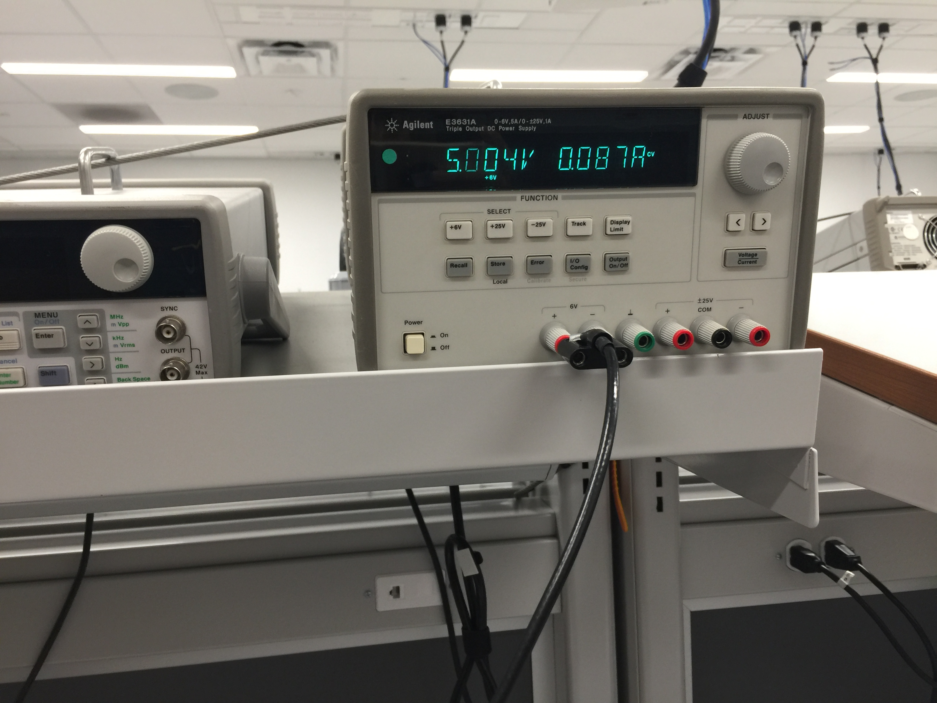Without music

E) Analysis and Discussion (give 1 or 2 sentence answers to these questions)

1. Briefly describe three errors in a DAC.

One could be that if change in one dac value does not change the output by the same amound. This is called non linearity and can cause waves to not be uniform at certain voltage ranges. Also the gain could be too high such that at some point the output gets saturated and this will cause the speaker to not expericne major voltage changes even at the time we diseire it to. And lastly there are offsets problems which will cause the voltage output to be off the exped output by some constant value. This will cause us problems of under flow or overflow saturation as well.

2) Calculate the data available and data required intervals in the SSI/DAC interface. Use these calculations to justify your choice of SSI frequency.

We need to hold the data for 8 us before and 5us after. Our ssi frequency is 8MHz, which gives us the hld time for 100us. This is much greater than the 13 us we need to hold for thus our choice of ssi freuncy is justified.

3) How is the frequency range of a spectrum analyzer determined?

We have to manually input the values we want to search through. Otherwise it analyzes from the minimum zero to maximum frequency it analyze. The intervals it checks at is is the divisor rate.

4) Why did we not simply drive the speaker directly from the DAC? I.e., what purpose is the TPA731?

It is an amplifier which we require to drive the sound louder and more clearer. Also as the current provided by the dac out would not be enough. Also the range has to be less thatn half the sampling frequency determined by the nyquest theorem.

**A software and report files must be uploaded to SVN as instructed by your TA.**

You may (for another +5% bonus) create sine-waves with envelopes similar to Figure 5.6. To get extra credit, these envelopes must have shapes that sound pretty and are independent of pitch. Notice in Figure 5.6 that the decay slope of the envelopes for 330 and 523 Hz are the same. I.e., the envelopes are not frequency dependent. A sinusoidal envelope sounds like the bowing action on a violin.

**WE did this and demoed it during the Lab**